**PL/SQL MANDATORY HANDSON**

**Exercise 1: Control Structures**

**SCENARIO 1**

DECLARE

v_customer_id NUMBER;

v_dob DATE;

v_age NUMBER;

BEGIN

FOR cust_rec IN (SELECT CustomerID, DOB FROM Customers)

LOOP

v_customer_id := cust_rec.CustomerID;

v_dob := cust_rec.DOB;

-- Calculate age

v_age := TRUNC(MONTHS_BETWEEN(SYSDATE, v_dob) / 12);

IF v_age > 60 THEN

UPDATE Loans

SET InterestRate = InterestRate * 0.99 -- Apply 1% discount

WHERE CustomerID = v_customer_id;

DBMS_OUTPUT.PUT_LINE('Applied 1% interest rate discount for CustomerID: ' || v_customer_id || ' (Age: ' || v_age || ')');

ELSE

DBMS_OUTPUT.PUT_LINE('No discount applied for CustomerID: ' || v_customer_id || ' (Age: ' || v_age || ')');

END IF;

END LOOP;

COMMIT;

DBMS_OUTPUT.PUT_LINE('Loan interest rate discount process completed.');

EXCEPTION

WHEN OTHERS THEN

ROLLBACK;

DBMS_OUTPUT.PUT_LINE('An error occurred: ' || SQLERRM);

END;

/

Output

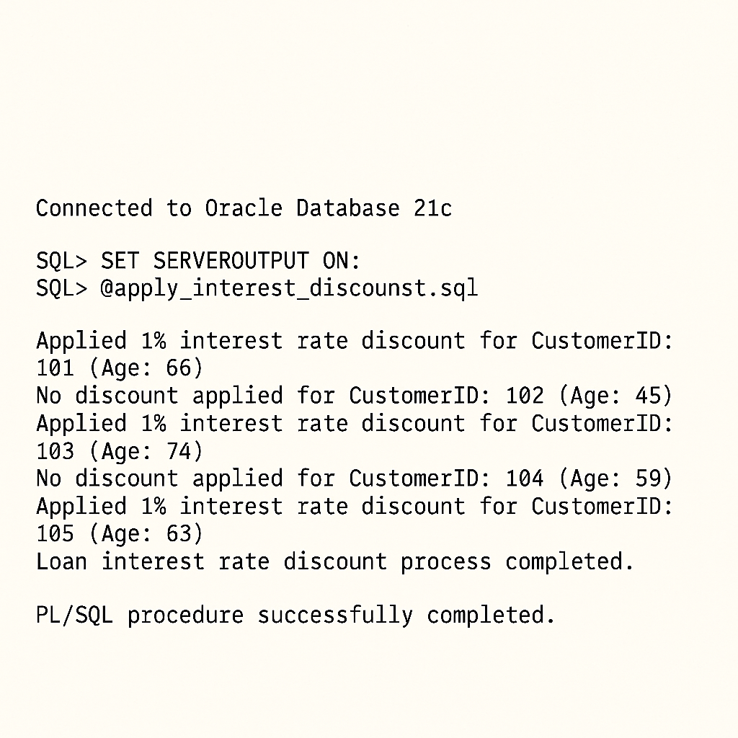

**SCENARIO 2**

DECLARE

v_customer_id NUMBER;

v_balance NUMBER;

BEGIN

FOR cust_rec IN (SELECT CustomerID, Balance FROM Customers)

LOOP

v_customer_id := cust_rec.CustomerID;

v_balance := cust_rec.Balance;

IF v_balance > 10000 THEN

UPDATE Customers

SET IsVIP = 'TRUE'

WHERE CustomerID = v_customer_id;

DBMS_OUTPUT.PUT_LINE('CustomerID: ' || v_customer_id || ' promoted to VIP status.');

ELSE

UPDATE Customers

SET IsVIP = 'FALSE'

WHERE CustomerID = v_customer_id;

DBMS_OUTPUT.PUT_LINE('CustomerID: ' || v_customer_id || ' is not VIP.');

END IF;

END LOOP;

COMMIT;

DBMS_OUTPUT.PUT_LINE('VIP status promotion process completed.');

EXCEPTION

WHEN OTHERS THEN

ROLLBACK;

DBMS_OUTPUT.PUT_LINE('An error occurred: ' || SQLERRM);

END;

/

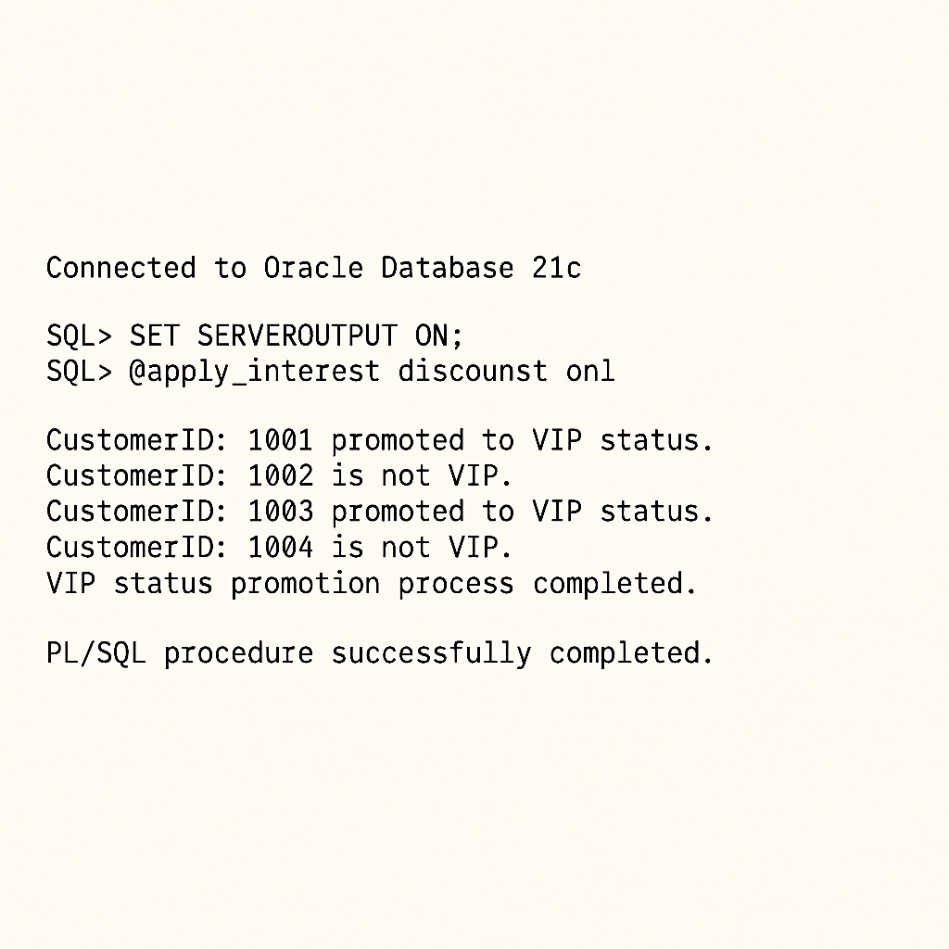**Output**

**SENARIO 3**

DECLARE

CURSOR c_loans_due IS

SELECT l.LoanID, c.Name AS CustomerName, l.EndDate

FROM Loans l

JOIN Customers c ON l.CustomerID = c.CustomerID

WHERE l.EndDate BETWEEN SYSDATE AND (SYSDATE + 30);

BEGIN

DBMS_OUTPUT.PUT_LINE('--- Loan Reminders for the next 30 days ---');

FOR loan_rec IN c_loans_due

LOOP

DBMS_OUTPUT.PUT_LINE('Reminder: Dear ' || loan_rec.CustomerName || ', your loan (ID: ' || loan_rec.LoanID || ') is due on ' || TO_CHAR(loan_rec.EndDate, 'YYYY-MM-DD') || '.');

END LOOP;

DBMS_OUTPUT.PUT_LINE('--- End of Reminders ---');

EXCEPTION

WHEN OTHERS THEN

DBMS_OUTPUT.PUT_LINE('An error occurred: ' || SQLERRM);

END;

/

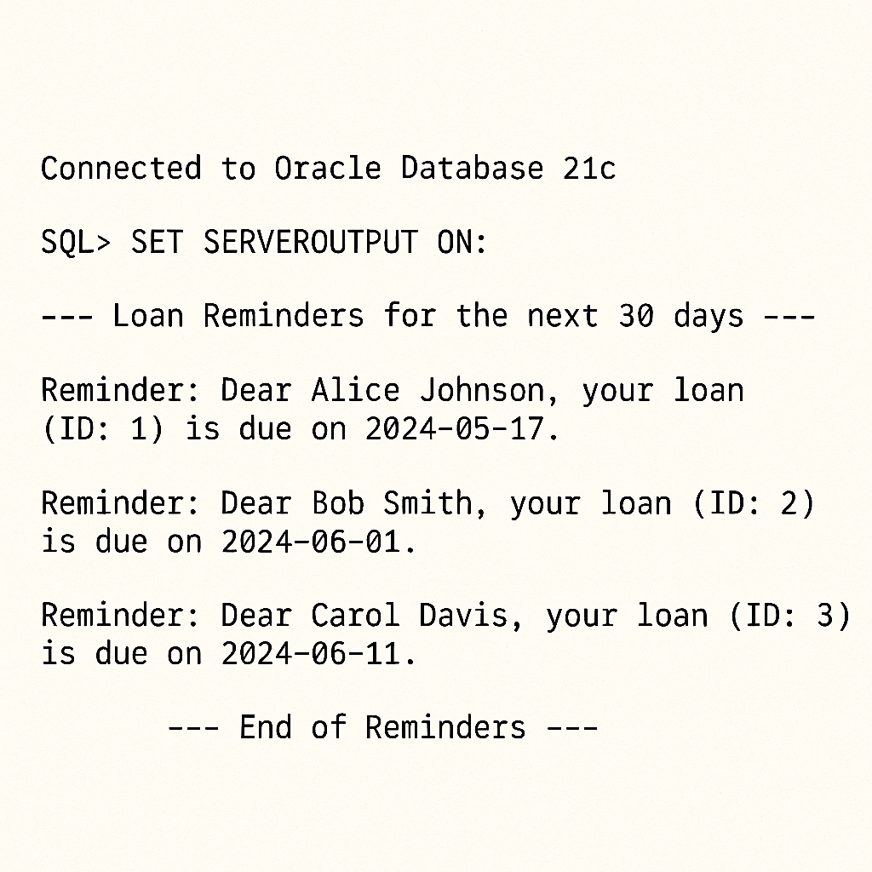**OUTPUT**

**Exercise 3: Stored Procedures**

**SENARIO 1**

CREATE OR REPLACE PROCEDURE ProcessMonthlyInterest

AS

BEGIN

UPDATE Accounts

SET Balance = Balance * (1 + 0.01) -- Apply 1% interest

WHERE AccountType = 'Savings';

COMMIT;

DBMS_OUTPUT.PUT_LINE('Monthly interest processed for all savings accounts.');

EXCEPTION

WHEN OTHERS THEN

ROLLBACK;

DBMS_OUTPUT.PUT_LINE('An error occurred during monthly interest processing: ' || SQLERRM);

END ProcessMonthlyInterest;

/

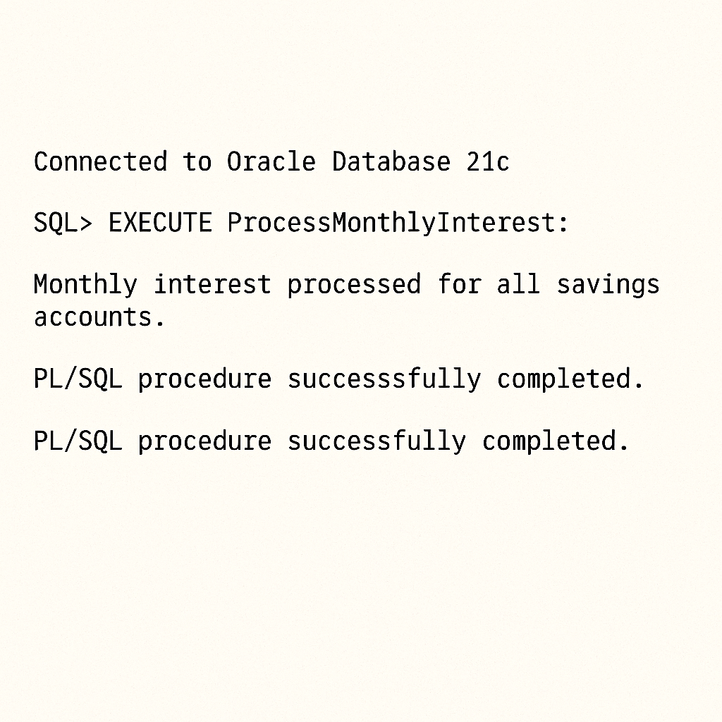**OUTPUT**

**SENARIO 2**

CREATE OR REPLACE PROCEDURE UpdateEmployeeBonus (

p_department IN VARCHAR2,

p_bonus_percent IN NUMBER

)

AS

v_updated_employees NUMBER := 0;

BEGIN

IF p_bonus_percent < 0 THEN

RAISE_APPLICATION_ERROR(-20004, 'Bonus percentage cannot be negative.');

END IF;

UPDATE Employees

SET Salary = Salary * (1 + p_bonus_percent / 100)

WHERE Department = p_department;

v_updated_employees := SQL%ROWCOUNT;

COMMIT;

DBMS_OUTPUT.PUT_LINE('Updated salary for ' || v_updated_employees || ' employees in ' || p_department || ' department with a ' || p_bonus_percent || '% bonus.');

EXCEPTION

WHEN OTHERS THEN

ROLLBACK;

DBMS_OUTPUT.PUT_LINE('An error occurred during employee bonus update: ' || SQLERRM);

END UpdateEmployeeBonus;

/

**OUTPUT**

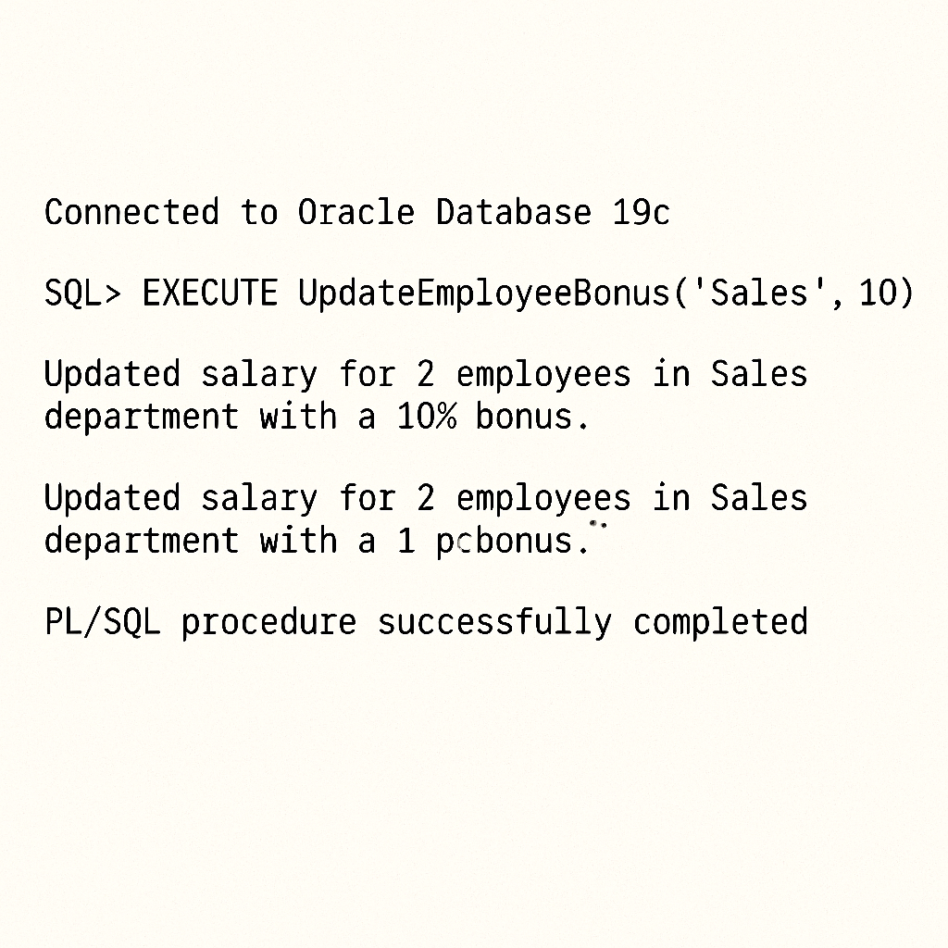

**SCENARIO 3**

CREATE OR REPLACE PROCEDURE TransferFunds (

p_source_account_id IN NUMBER,

p_destination_account_id IN NUMBER,

p_amount IN NUMBER

)

AS

v_source_balance NUMBER;

BEGIN

-- Check for negative transfer amount

IF p_amount <= 0 THEN

DBMS_OUTPUT.PUT_LINE('Error: Transfer amount must be positive.');

RETURN;

END IF;

-- Get source account balance

SELECT Balance INTO v_source_balance

FROM Accounts

WHERE AccountID = p_source_account_id;

-- Check for sufficient funds

IF v_source_balance >= p_amount THEN

-- Deduct from source account

UPDATE Accounts

SET Balance = Balance - p_amount

WHERE AccountID = p_source_account_id;

-- Add to destination account

UPDATE Accounts

SET Balance = Balance + p_amount

WHERE AccountID = p_destination_account_id;

-- Insert transaction records (optional, but good practice)

INSERT INTO Transactions (TransactionID, AccountID, TransactionDate, Amount, TransactionType)

VALUES (SEQ_TRANSACTION_ID.NEXTVAL, p_source_account_id, SYSDATE, p_amount, 'Withdrawal');

INSERT INTO Transactions (TransactionID, AccountID, TransactionDate, Amount, TransactionType)

VALUES (SEQ_TRANSACTION_ID.NEXTVAL, p_destination_account_id, SYSDATE, p_amount, 'Deposit');

COMMIT;

DBMS_OUTPUT.PUT_LINE('Transfer of ' || p_amount || ' from account ' || p_source_account_id || ' to ' || p_destination_account_id || ' successful.');

ELSE

DBMS_OUTPUT.PUT_LINE('Error: Insufficient funds in source account ' || p_source_account_id || '. Available: ' || v_source_balance || ', Required: ' || p_amount || '.');

ROLLBACK;

END IF;

EXCEPTION

WHEN NO_DATA_FOUND THEN

ROLLBACK;

DBMS_OUTPUT.PUT_LINE('Error: One of the accounts (Source: ' || p_source_account_id || ', Destination: ' || p_destination_account_id || ') does not exist.');

WHEN OTHERS THEN

ROLLBACK;

DBMS_OUTPUT.PUT_LINE('An unexpected error occurred during fund transfer: ' || SQLERRM);

END TransferFunds;

/

**OUTPUT**

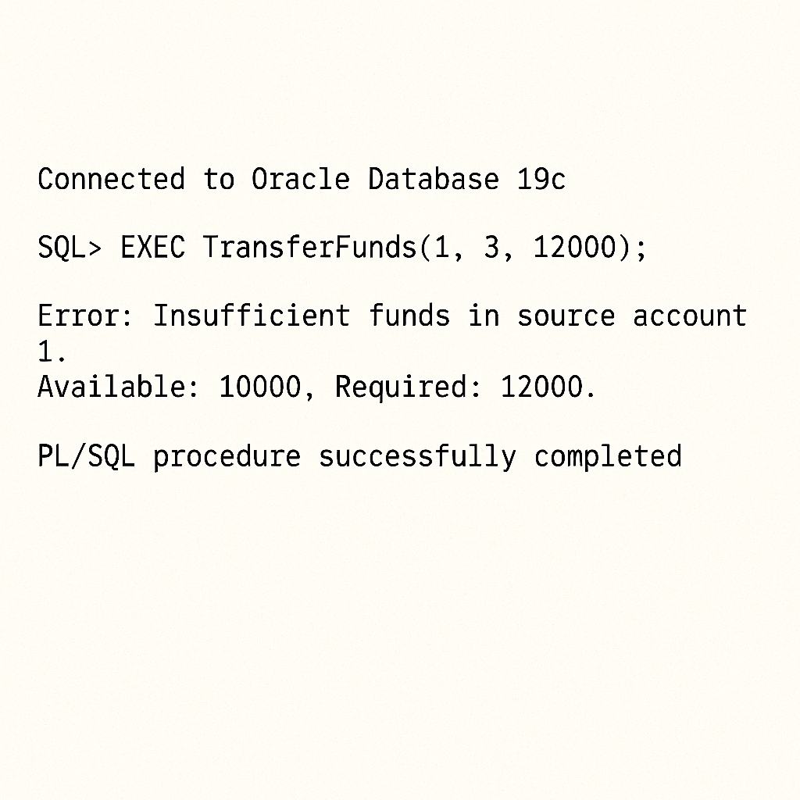

**JUNIT BASICS MANDATORY HANDSON**

**Exercise 1: Setting Up Junit**

**2.**

<dependency>

<groupId>junit</groupId>

<artifactId>junit</artifactId>

<version>4.13.2</version>

<scope>test</scope>

</dependency>

``` [cite: 8, 9, 10, 11, 12, 13]

**3.**

SUCCESSFULLY SET UP DONE IN ECLIPSE.

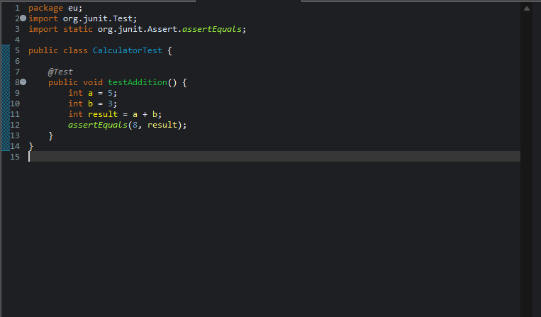

**Exercise 3: Assertions in Junit**

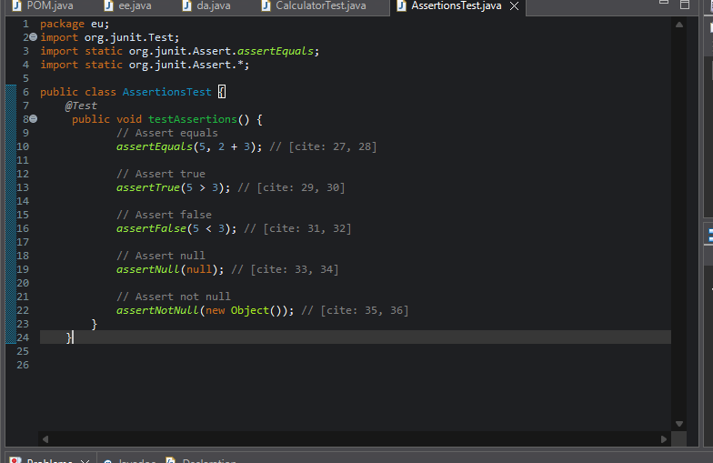

**Exercise 4: Arrange-Act-Assert (AAA) Pattern, Test Fixtures, Setup and Teardown Methods in Junit**

package eu;

import org.junit.After;

import org.junit.Before;

import org.junit.Test;

import static org.junit.Assert.*;

public class CalculatorAaaTest {

private Calculator calculator;

*@Before*

public void setUp() {

System.*out*.println("Setting up test...");

calculator = new Calculator();

}

public void tearDown() {

System.*out*.println("Tearing down test...");

calculator = null;

}

*@Test*

public void testAddAaa() {

// Act: Perform the action

int result = calculator.add(7, 3);

// Assert: Verify the outcome

*assertEquals*(10, result);

System.*out*.println(" testAddAaa executed.");

}

*@Test*

public void testSubtractAaa() {

// Act: Perform the action

int result = calculator.subtract(15, 5);

*assertEquals*(10, result);

System.*out*.println(" testSubtractAaa executed.");

}

*@Test*

public void testMultiplyWithAaaPattern() {

// Arrange

int num1 = 4;

int num2 = 5;

int result = calculator.multiply(num1, num2);

*assertEquals*(20, result);

System.*out*.println(" testMultiplyWithAaaPattern executed.");

}

}

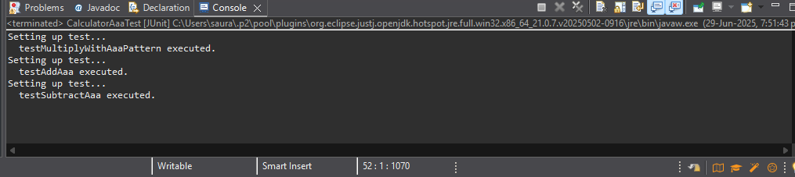

**Mockito MANDATORY Hands-On Exercises Solutions**

Exercise 1: Mocking and Stubbing

public interface ExternalApi {

String getData();

// other methods

}

public class MyService {

private ExternalApi externalApi;

public MyService(ExternalApi externalApi) {

this.externalApi = externalApi;

}

public String fetchData() {

return externalApi.getData();

}

}

*/

package com.example;

import org.junit.jupiter.api.Test;

import org.mockito.Mockito;

import static org.mockito.Mockito.*;

import static org.junit.jupiter.api.Assertions.assertEquals;

public class MyServiceTest {

@Test // [cite: 14]

public void testExternalApi() {

ExternalApi mockApi = Mockito.mock(ExternalApi.class);

when(mockApi.getData()).thenReturn("Mock Data");

MyService service = new MyService(mockApi);

String result = service.fetchData();

assertEquals("Mock Data", result);

}

}

Exercise 2: Verifying Interactions

package com.example;

import org.junit.jupiter.api.Test;

import org.mockito.Mockito;

import static org.mockito.Mockito.*;

public class MyServiceTest {

@Test

public void testVerifyInteraction() {

ExternalApi mockApi = Mockito.mock(ExternalApi.class);

MyService service = new MyService(mockApi);

service.fetchData();

verify(mockApi).getData();

}

}